Artificial Intelligence Lab 4
Informed Search: Heuristics & A*
Task 1: g, h and f values for the first three expansions
Student Name: Ali Abbas | Roll No: 030

1. Given Data
For this task I used the campus graph and the heuristic given in the lab manual. The edge costs are travel-time units.
Edge | Cost
S → A | 1
S → B | 4
A → C | 2
B → G | 5
C → G | 3

Node | S | A | B | C | G
h(n) | 5 | 4 | 4 | 2 | 0

Start node: S. Goal node: G.
Formulas I used: g(child) = g(parent) + edge cost, and f(n) = g(n) + h(n).
Order of successors: I took the successors in the same order as they are written in the graph. So S gives A first and then B. A, B and C have only one successor each.
Tie-breaking: In the code every queue entry is stored as (f, g, node, path) using heapq. So the entry with the smallest f comes out first. If the f is the same, the smaller g comes first, and if g is also the same then the node names are compared (A before B and so on). I used this same rule for every selection.
Counting: I count a node as expanded when I take it out of the queue and look at its successors. I only did the first three expansions, as the task says.

2. Manual Calculation

Starting frontier
At the start the queue only has S. f(S) = g(S) + h(S) = 0 + 5 = 5.
Node | g | h | f = g + h
S | 0 | 5 | 5

Expansion 1: S
Selected node: S
S is the only entry in the queue, so it gets picked. It is not the goal, so I expand it.
Node | g | h | f = g + h
S | 0 | 5 | 0 + 5 = 5

Frontier after removing S: empty.
Successors of S (in graph order):
- A: g(A) = g(S) + cost(S,A) = 0 + 1 = 1. h(A) = 4, so f(A) = 1 + 4 = 5. I had not reached A before, so I add it to the queue.
- B: g(B) = g(S) + cost(S,B) = 0 + 4 = 4. h(B) = 4, so f(B) = 4 + 4 = 8. B is also new, so I add it.
Frontier after expansion 1:
Node | g | h | f = g + h
A | 1 | 4 | 1 + 4 = 5
B | 4 | 4 | 4 + 4 = 8

Expansion 2: A
Selected node: A
The queue has A with f = 5 and B with f = 8. A has the smaller f, so A is picked. The two f values are not equal, so I did not need the tie-breaking rule here.
Node | g | h | f = g + h
A | 1 | 4 | 1 + 4 = 5

Frontier after removing A:
Node | g | h | f = g + h
B | 4 | 4 | 4 + 4 = 8

Successors of A:
- C: g(C) = g(A) + cost(A,C) = 1 + 2 = 3. h(C) = 2, so f(C) = 3 + 2 = 5. C is new, so I add it.
Frontier after expansion 2:
Node | g | h | f = g + h
C | 3 | 2 | 3 + 2 = 5
B | 4 | 4 | 4 + 4 = 8

Expansion 3: C
Selected node: C
The queue has C with f = 5 and B with f = 8. C has the smaller f, so C is picked. Again there is no tie.
Node | g | h | f = g + h
C | 3 | 2 | 3 + 2 = 5

Frontier after removing C:
Node | g | h | f = g + h
B | 4 | 4 | 4 + 4 = 8

Successors of C:
- G: g(G) = g(C) + cost(C,G) = 3 + 3 = 6. h(G) = 0, so f(G) = 6 + 0 = 6. G is new, so I add it.
Frontier after expansion 3:
Node | g | h | f = g + h
G | 6 | 0 | 6 + 0 = 6
B | 4 | 4 | 4 + 4 = 8

3. Summary of the Three Expansions
# | Selected | g | h | f | Frontier after removing it | Frontier after adding successors
1 | S | 0 | 5 | 5 | empty | A (f=5), B (f=8)
2 | A | 1 | 4 | 5 | B (f=8) | C (f=5), B (f=8)
3 | C | 3 | 2 | 5 | B (f=8) | G (f=6), B (f=8)

4. Why the Next Node Is Picked
After expansion 3 the queue has G with f = 6 and B with f = 8. G has the smaller f, so it is picked next, before B. G is the goal, so the search stops there and gives cost 6 with the path S → A → C → G. B never gets expanded.
The f values of the nodes I picked were 5, 5, 5 and then 6, so they never went down. This fits with the heuristic being consistent, because it passes the check h(u) ≤ cost(u,v) + h(v) on every edge. Also, at no point in this run did two entries have the same f, so the tie-breaking rule did not actually decide anything.
Task 2: A* and UCS on the same graph, expanded nodes

1. What I Did
I ran two searches on the same graph from the manual, with the same start S and the same goal G.
- Run 1, A*: uses the heuristic given in the manual (S:5, A:4, B:4, C:2, G:0).
- Run 2, UCS: the same code, but every h value is set to 0. Then f = g, so it behaves like UCS.
Nothing else was changed between the two runs. The graph, the queue code, the (f, g, node, path) tie-breaking and the successor order are all the same.
Counting rule (same for both runs): a node is counted as expanded only when I look at its successors. When the goal is popped I write it in the trace but I do not count it. Old queue entries (stale entries) are skipped and not counted. I keep a separate counter for them.
Cost check: the cost returned by the search is compared with a second total that I add up from the edge weights along the returned path (the path_cost function).
One small change from the manual code: I put the stale check before the goal check, so an old goal entry can never be returned. It makes no difference on this graph.

2. Code
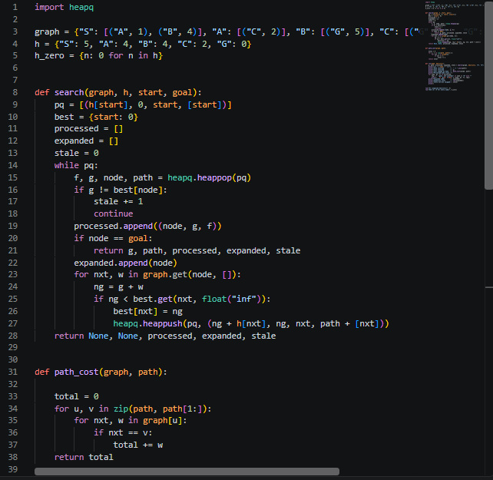
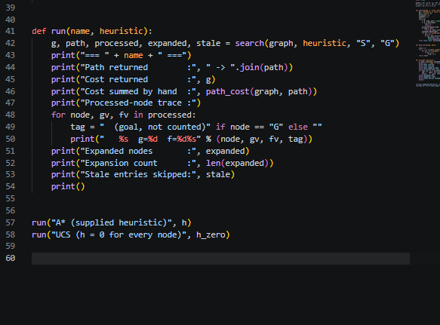

3. Output
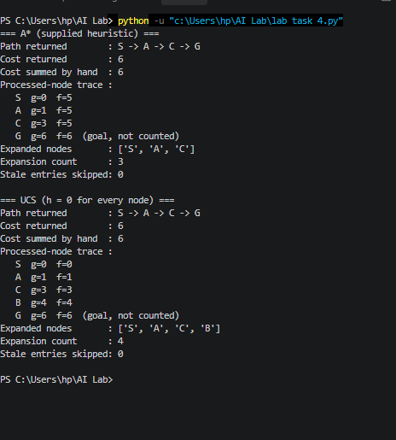

4. Comparison Table
 | A* (supplied h) | UCS (h = 0)
Path returned | S → A → C → G | S → A → C → G
Cost returned | 6 | 6
Cost summed from edges | 1 + 2 + 3 = 6 | 1 + 2 + 3 = 6
Processed-node trace | S, A, C, G | S, A, C, B, G
Expanded nodes | S, A, C | S, A, C, B
Expansion count | 3 | 4
Stale entries skipped | 0 | 0
Count if goal was also counted | 4 | 5

5. Explanation
Same answer. Both runs return S → A → C → G with cost 6, and my own sum of the edge weights is also 6. So, on this graph both found the best route.
Why UCS expanded one more node. The extra node is B. In UCS the f value is just g, so B has f = 4, which is smaller than f(G) = 6. That means B comes out of the queue before G and must be expanded. Its only edge is B → G, which would give g(G) = 4 + 5 = 9. That is not better than the 6 already known, so nothing is added. This expansion did not help. In A* the heuristic makes f(B) = 4 + 4 = 8, which is bigger than f(G) = 6, so G comes out first and the search stops before B is ever expanded.
Stale entries. There were 0 stale entries in both runs, so the stale check never skipped anything, and it does not cause any difference between the two counts. This is because G was only added to the queue once (through C, with g = 6). The route through B gives 9, which is not an improvement, so a second entry for G was never created.
Goal counting. In both runs G is the last node popped. I log it but do not count it. If I did count it, A* would be 4 and UCS would be 5. The difference would still be 1, so this rule does not change the comparison.
Limit of this result. This is one small graph with 3 expansions against 4. It shows that A* skipped one node here, but it does not prove anything about other graphs.
Artificial Intelligence Lab 4
Informed Search: Heuristics & A*
Task 3: Changing one heuristic value to an overestimate

1. What I Changed
I changed only one heuristic value. Everything else is the same as in Task 2: the graph, start S, goal G, the other h values, the queue code, the tie-breaking and the counting rule.
Node | Original h | Modified h | True remaining cost | Overestimate by
C | 2 | 10 | 3 | 10 - 3 = 7

The true remaining cost of C is 3 because C has only one edge, C → G, with cost 3. The program also finds this value with path_cost(graph, ["C", "G"]). Since h(C) = 10 is more than 3, this heuristic is not admissible any more. All the other h values are unchanged.

2. Code
The Task 3 part is added at the end of the same file, from line 62.
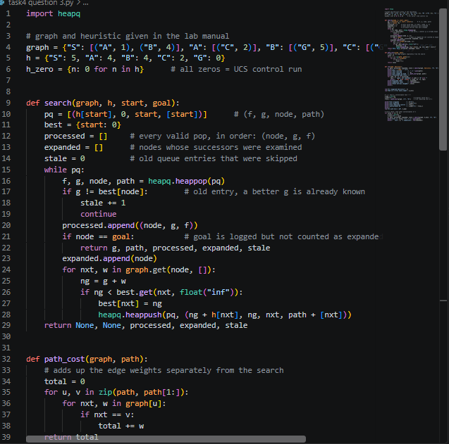
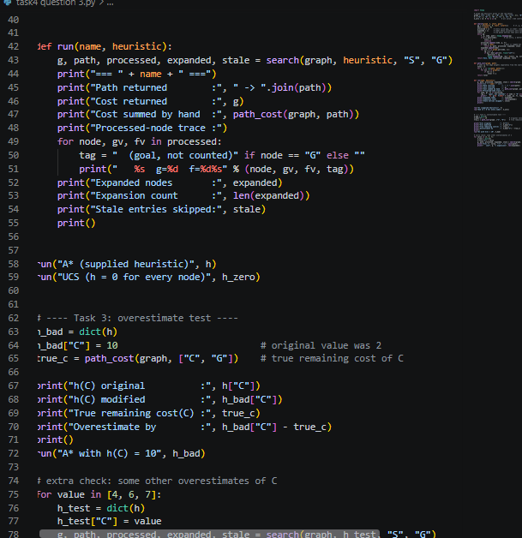

3. Output
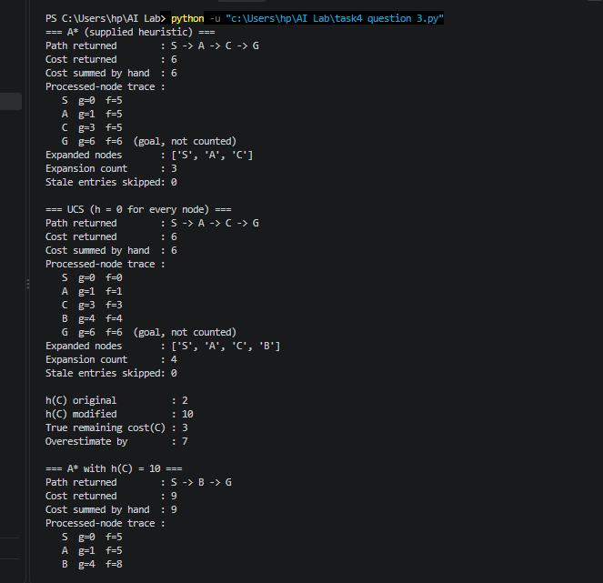
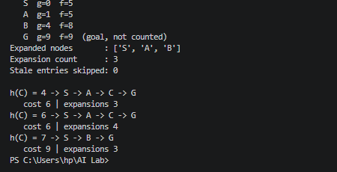

4. Result Compared with the Original A* Run
 | A* with h(C) = 2 (original) | A* with h(C) = 10
Path returned | S → A → C → G | S → B → G
Cost returned | 6 | 9
Cost summed from edges | 6 | 9
Processed-node trace | S, A, C, G | S, A, B, G
Expanded nodes | S, A, C | S, A, B
Expansion count | 3 | 3
Stale entries skipped | 0 | 0

5. Explanation
Did the result change? Yes. The path changed from S → A → C → G to S → B → G, and the cost went from 6 to 9, which is 3 more than the best cost. The expansion count stayed at 3, but the expanded nodes are different (S, A, C became S, A, B). So the count alone would not have shown the problem. I had to look at the path and the cost.
What happened step by step. After A is expanded, C is added with g = 3 and h = 10, so f(C) = 3 + 10 = 13. B is waiting in the queue with f(B) = 4 + 4 = 8. B has the smaller f, so B is expanded next and G is added through B with g = 4 + 5 = 9 and f = 9 + 0 = 9. Now the queue has G with f = 9 and C with f = 13. G has the smaller f, so G is popped and the search stops with cost 9. The cheaper way to G through C (cost 6) is never looked at.
Why an overestimate removes the guarantee. A* picks nodes by f, so it treats f(n) as a lower bound on the cost of the best route through n. This works when h never goes above the true remaining cost. Here the best route through C costs 6, but f(C) = 13, so f is not a lower bound any more. That is why a goal entry with f = 9 could be picked before C was even tried.
A run can look unchanged and still be unsafe. h(C) = 4 and h(C) = 6 are also overestimates (true cost is 3), but the answer stays correct. I checked this in the program and the results are in the table below.
h(C) | Path returned | Cost | Expansions | Why
4 | S → A → C → G | 6 | 3 | f(C) = 3 + 4 = 7, which is less than f(B) = 8, so C is still picked before B.
6 | S → A → C → G | 6 | 4 | f(C) = 9 is more than f(B) = 8, so B is expanded first. After that C and G both have f = 9, and C has the smaller g (3 against 9), so C is picked first.
7 | S → B → G | 9 | 3 | f(C) = 10 is more than f(G) = 9, so G is picked first and the answer is wrong.

So if I had only tried h(C) = 4 or 6, the result would have looked fine and I could have wrongly decided the heuristic is safe. Both are overestimates, so the guarantee is gone even though those runs gave the right answer. h(C) = 10 shows the failure in this graph.

